**A**

Project Report On

**“COACHING CENTER”**

For

**POSSIBLE COACHING CENTER**

Submitted By

**Mr.Sk.shahid Sk.shakir**

**Mr**

**Roll No. - 128**

Guided By

**PROF. ANKITA TIWARI MAM**

In Particular Fulfillment Of The Degree Of

**MASTER OF COMPUTER APPLICATION**

Under

**KAVAYITRI BAHINABAI CHAUDHARI NORTH MAHARASHTRA UNIVERSITY, JALGAON**

Submitted To



**INSTITUDE OF MANAGEMENT & RESERCH, Jalgaon (IMR)**



**CERTIFICATE**

This is to certify that Miss Vaishnavi Vishnu Tayde a student of MCA (Master of Computer Application) from Institute of Management and Research, Jalgaon has completed the full time Industrial Training with project titled “Coaching Center” at Possible Coaching Center Chopda.

He has submitted satisfactory report in partial fulfillment of the requirement for the award of the degree of Master of Computer Application (MCA) during academic year 2021-2022.

(Mr. Uday S. Chatur) (Prof. Dr. Shilpa K. Bendale)

Internal Guide Director

External Examiner External Examiner

**ACKNOWLEGMENT**

I express my sincere thanks to Mr. Uday Chatur sir (Project Guide) for the encouragement, insistence, assistance, and valuable guidance for completion of this project. I would like to thank colleagues Miss Ankita Tiwari Mam, one or other way has helped me to learn the tricks and trades of software development.

I would not be doing justice if I forget Director Prof. Dr. Shilpa Bendale , and all my faculty members who has been constant source of inspiration to me throughout my completion of M.C.A at Institute of Management and Research, Jalgaon.

Last but not the least I would like to thank my family and friends for being so supportive and generous to me throughout my learning days.

**ABSTRACT**

Possible Coaching Center in Jalgaon offers short-term courses and Certificate courses. Inclusive of comprehensive learning, the long-term programmes feature subject such as web development, financial accountancy, computer application and programming, information technology, multimedia and web designing. Some of the short-term courses cover topics like Windows XP,7,8,10, vista MS Office, DTP (Desk Top Publishing), Web Designing, Multimedia, Tally ERP 9, C, C++, and Visual Basic. Walk into this Center all through the week between 09:30-18:30. Pay in cash, Cheques.

Possible Coaching Center in Jalgaon, Jalgaon has been offering professional training to student. It specialises and is well known for training students as well as working professionals in accounting, web designing, programming languages and networking. It is run and managed by a seasoned professionals who leads a team od educators and trainers having relevant domain expertise. These easy-to follow courses are primarily aimed at students, working professionals as well as IT professionals who want to enhance their knowledge and further their career prospects.

**INDEX**

|  |  |  |
| --- | --- | --- |
| **Sr. No** | **Topic Name** | **Page No** |
| **1** | **Introduction** | **6** |
| **2** | **Objectives** | **7** |
| **3** | **Purpose** | **8** |
| **4** | **Input Screen** | **10** |
|  | **Demo.html File** | **10** |
|  | **Demo2.html File** | **12** |
|  | **Sample.html File** | **14** |
| **5** | **Output Screen** | **15** |
|  | **Home Page** | **15** |
|  | **First Page** | **16** |
|  | **Second Page** | **17** |
| **6** | **Conclusion** | **18** |

**INTRODUCTION**

What is a coaching center? Coaching Center is a term for private educational institutes that offer classes for almost all the subjects. They prepare students for specific examinations and tests. That is why students opt for these classes for preparation for university or college entrance examinations. Such centers are very popular nowadays because of the increased interest in programming Languages . A lot of school teachers or university professors earn their supplementary income through a Coaching Center. However, their primary focus is on rote learning. Due to the immense academic competition amongst students to get into the best graduate school, both students and the parents have little choice but to engage with these. As parents want the best for their children, this trend of Coaching Centers isn’t dying anytime soon.

Coaching Center is accommodating for students looking for one-to-one interactions and special instructions. These centers are also extremely convenient for teachers. Unlike teachers at schools, they are paid mostly on an hourly basis with no boundaries.

At a Coaching Centre, regular tests and assessments are held. They boost the students’ confidence while helping them prepare better. State Governments across India have started framing guidelines to regulate these centers as they are running as a parallel education system.

**OBJECTIVE**

* **To provide highest quality education to the students**
* **Deliver the best study material featuring concise and compete theory lessons**
* **Help the students to realize their potential**
* **To expand and enrich the knowledge base of the students**
* **Customized teaching techniques tailor made for each and every student**
* **Always act in the best interest of students**

**PURPOSE**

**1. Developing Leadership**

Developing leadership is one of the main purposes of coaching because coaching brings about open-minded thinking among leaders. Coaching strengthens leadership by improving in areas such as communication, active listening, appreciating an individual’s hard work, crediting and giving positive feedback, trust-building among subordinates, appreciative inquiry, managing their reactions/emotions in stressful situations, having compassion and empathy towards others.

**2. Creating Self-Discipline**

Self-discipline can be defined as the ability to push oneself, stay motivated and take action to reach a certain goal. Self-discipline is one of the purposes of coaching to increase willpower, self-control, self-confidence, self-belief, and the ability to fulfill your goal. Self-discipline gives you a healthy-positive outlook on life.

**3. Building Self-Belief System**

Self-belief is an individual’s belief in their own ability to complete defined targets and achieve their goals. Self-trust is the basis of the self-belief system. To build a self-belief system one might opt for confidence-coaching, leadership coaching, public-speaking coaching, or conflict resolution coaching.

**4. Creating Motivation**

Motivation can be defined as energizing, sustaining, and increasing employee efforts. The mark of a successful leader/coach lies in how well they motivate their subordinates/clients. Creating motivation is one of the purposes of coaching to improve employees’ efficiency and effectiveness, optimistic approach, willingness to work harder, make optimum use of resources, co-operative attitude, boosts morale and satisfaction, and an overall higher rate of productivity.

**5. Improving Self-Awareness**

Self-awareness means being aware of different aspects of self like traits, behaviors and feelings. Viewing yourself as you are without being clouded by ego or self-criticism is self-awareness. The purpose of Self-awareness is to increase confidence, creativity, making [sounder decisions](https://www.jstor.org/stable/20152338?seq=1#page_scan_tab_contents), building [stronger relationships](http://www.emeraldinsight.com/doi/abs/10.1108/02683940310484008), and [communicating more effectively](http://www.emeraldinsight.com/doi/abs/10.1108/EJTD-04-2015-0031?journalCode=ejtd).

**6. Maximizing Potential**

Maximum potential refers to being the best version of yourself and having complete efficiency and productivity. Even the most potentially talented executive may not be able to develop their skills to the fullest without coaching. Coaching brings order and structure into the client’s life to maximize performance.

**\*\*\* Input Screen \*\*\***

**Demo.html File**

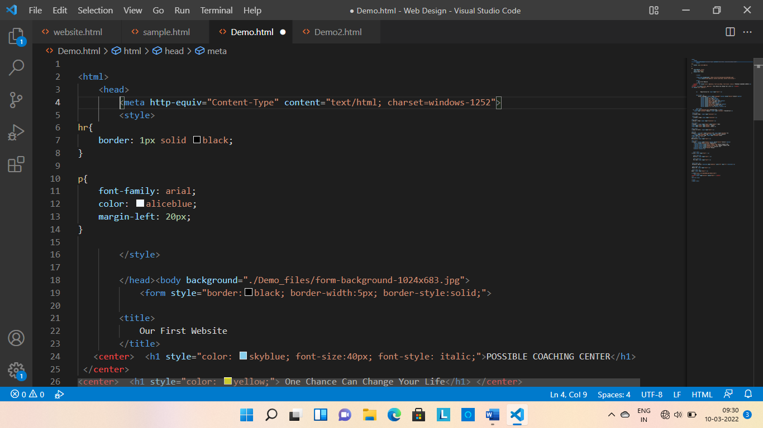

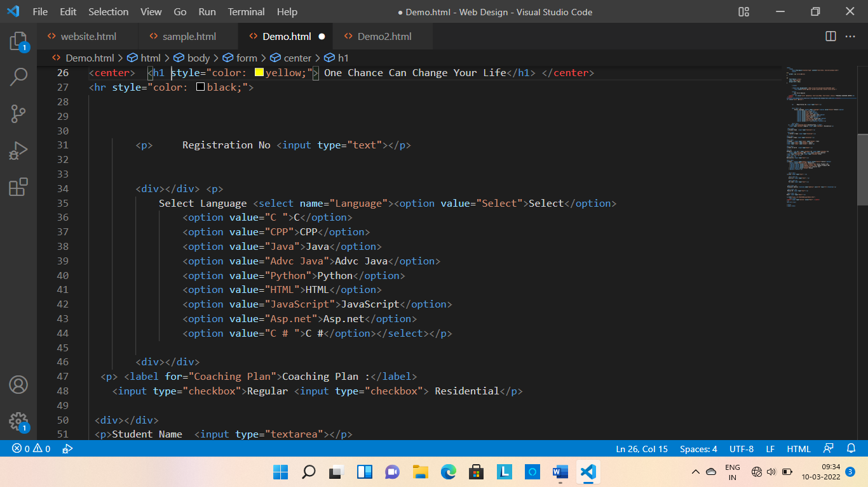

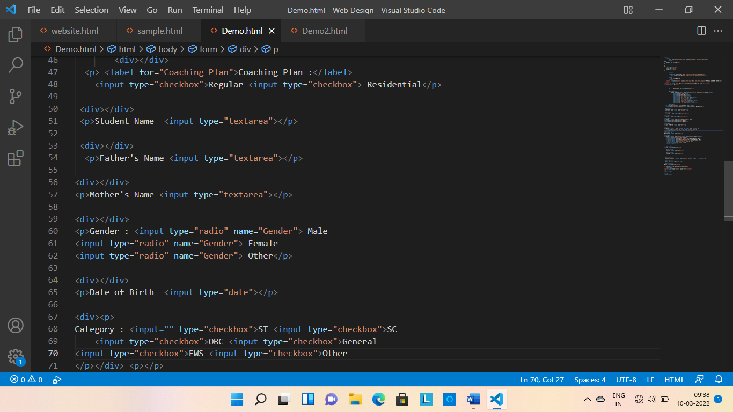

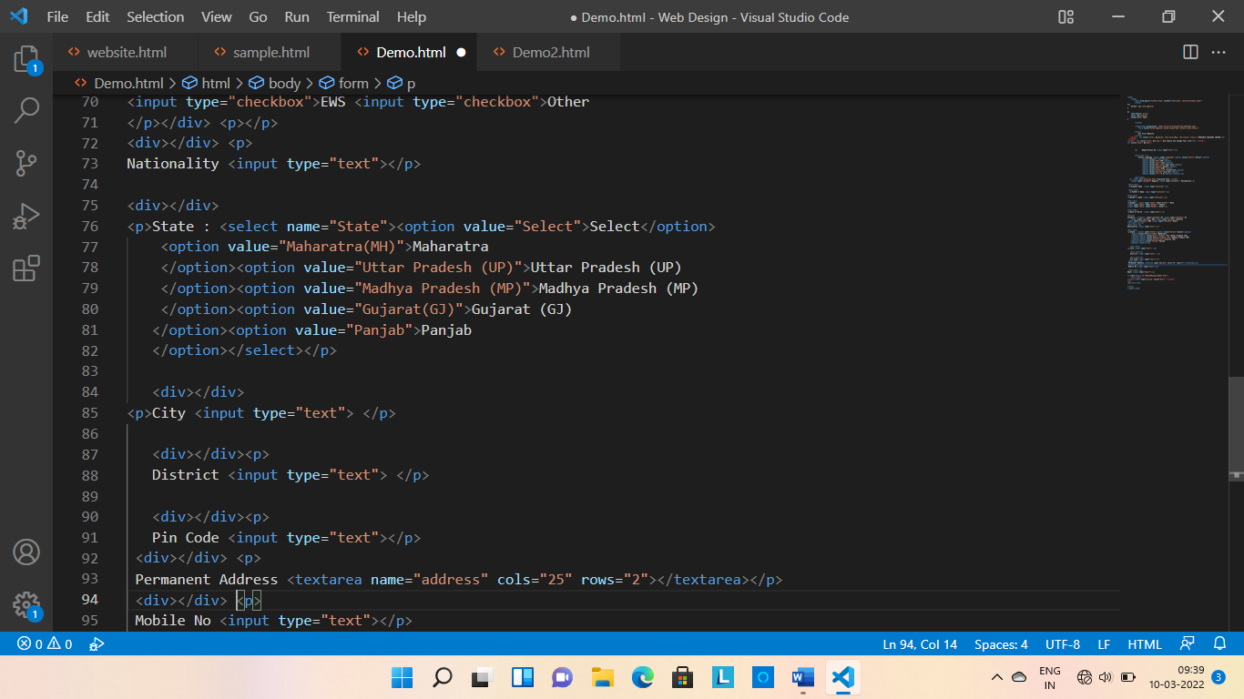



**Demo2.html File**

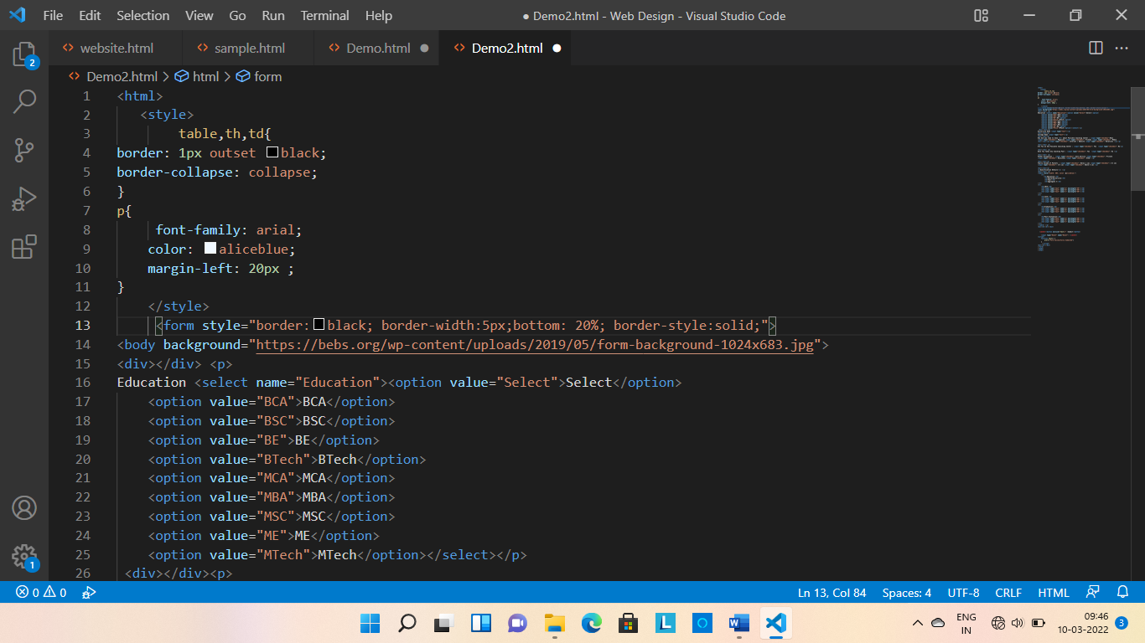

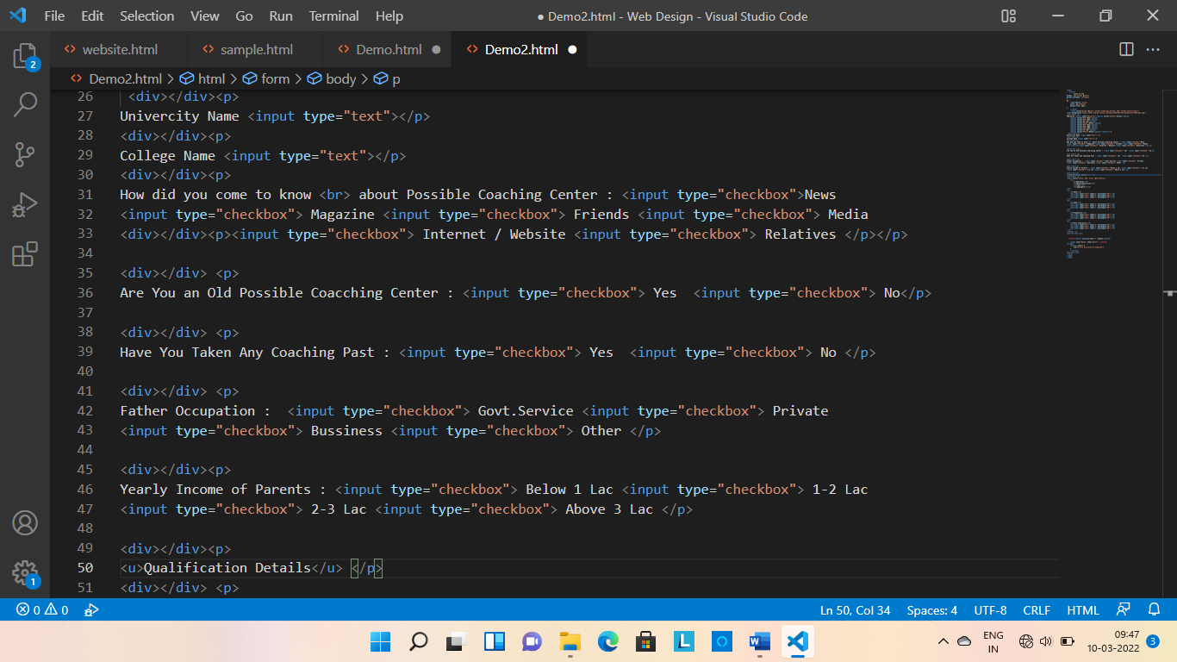

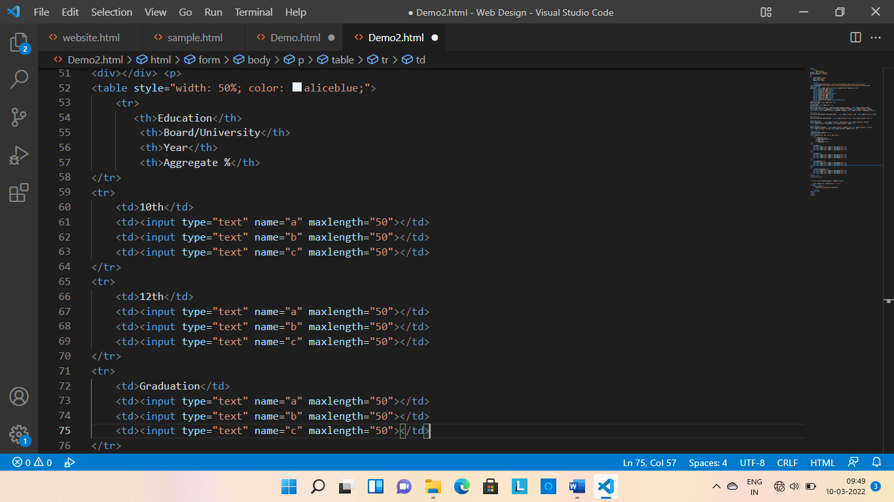

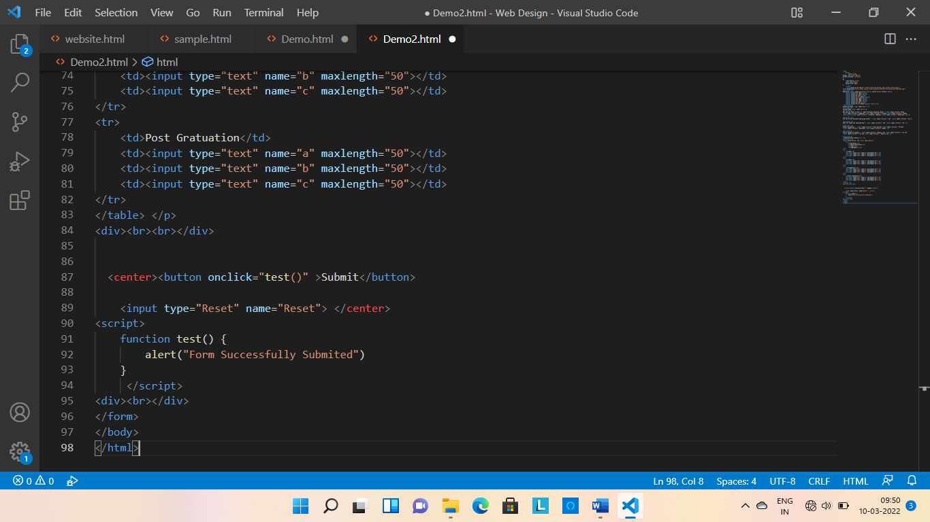

**Sample.html File**

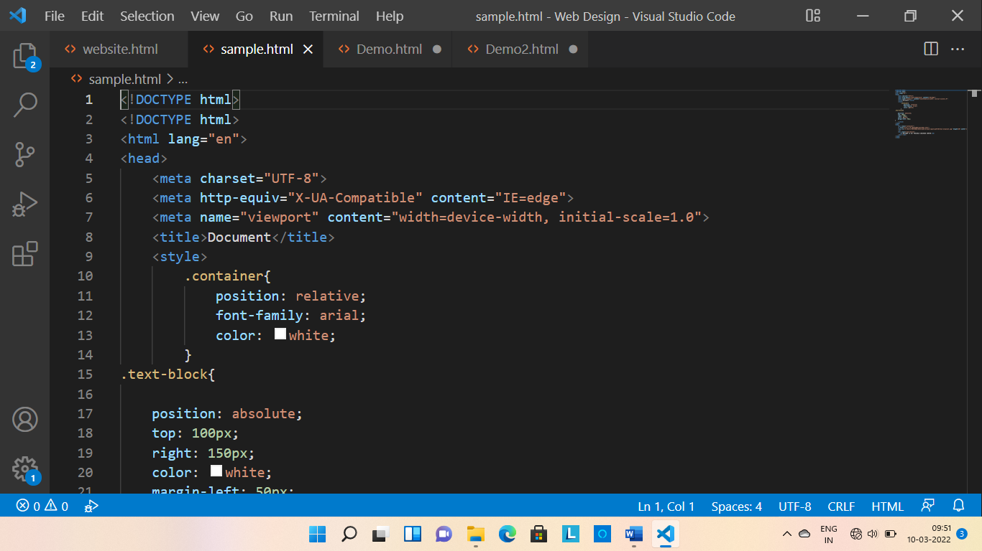

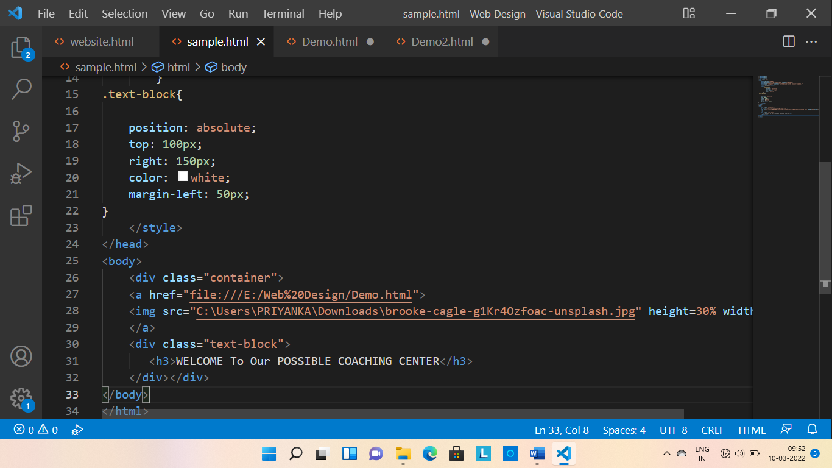

**In the above files we have used HTML, CSS as well as Javascript.**

**\*\*\* Output Screen \*\*\***

**Home Page**

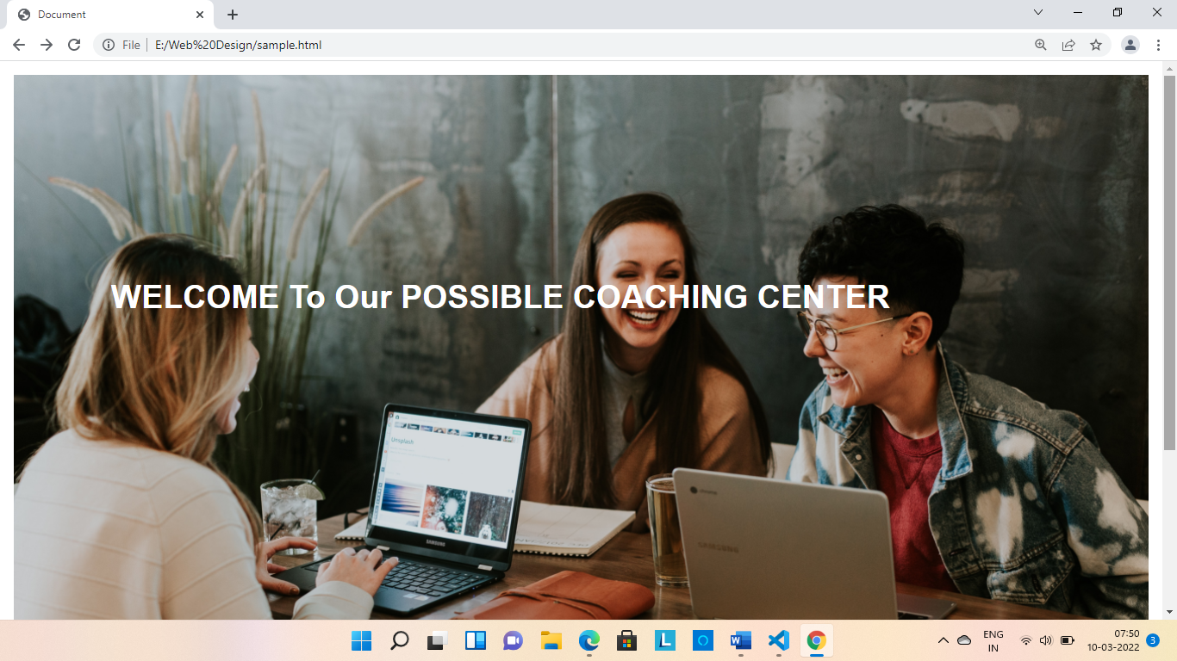

**This is our home page of form. above we add image using an image source tag of html and we write some text on that image.**

**First Page of**

**Possible Coaching Center Form**

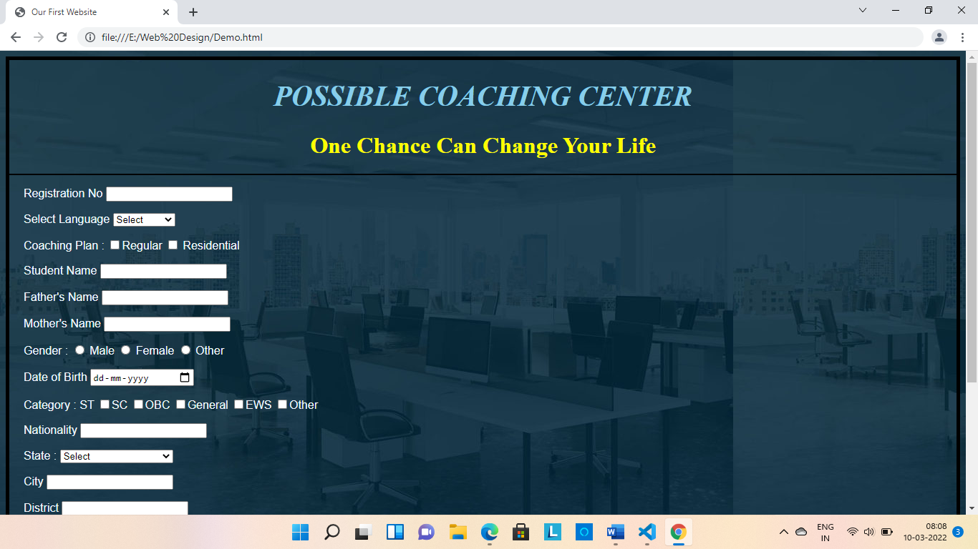

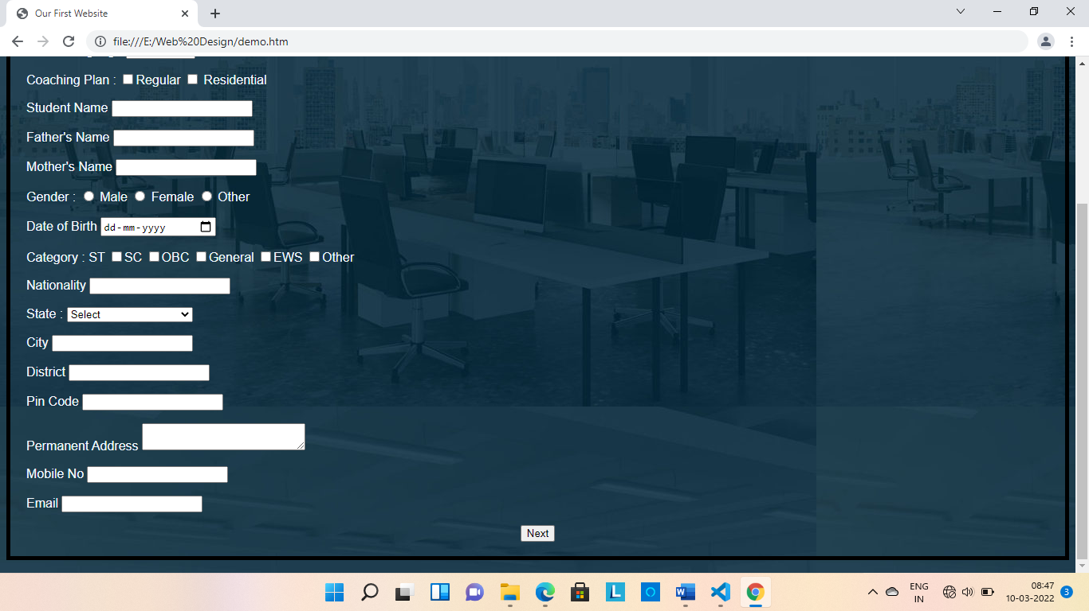

**Second Page of**

**Possible Coaching Center Form**

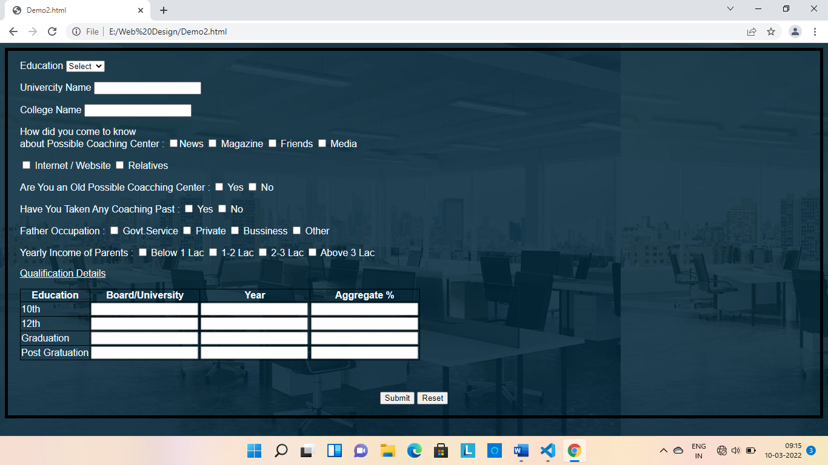

**Conclusion**

**Coaching classes are always played a role in proper guidance. If you want to stay in the competition then you need a regular and routine life without having any stress. Don’t force your children to attend the classes. Make them understand that these types of classes have Actually attended a coaching class has lots of benefits which will teach you more and make you update more as this type of classes is full with fresh flocks of students and their ideas and curiosity.**